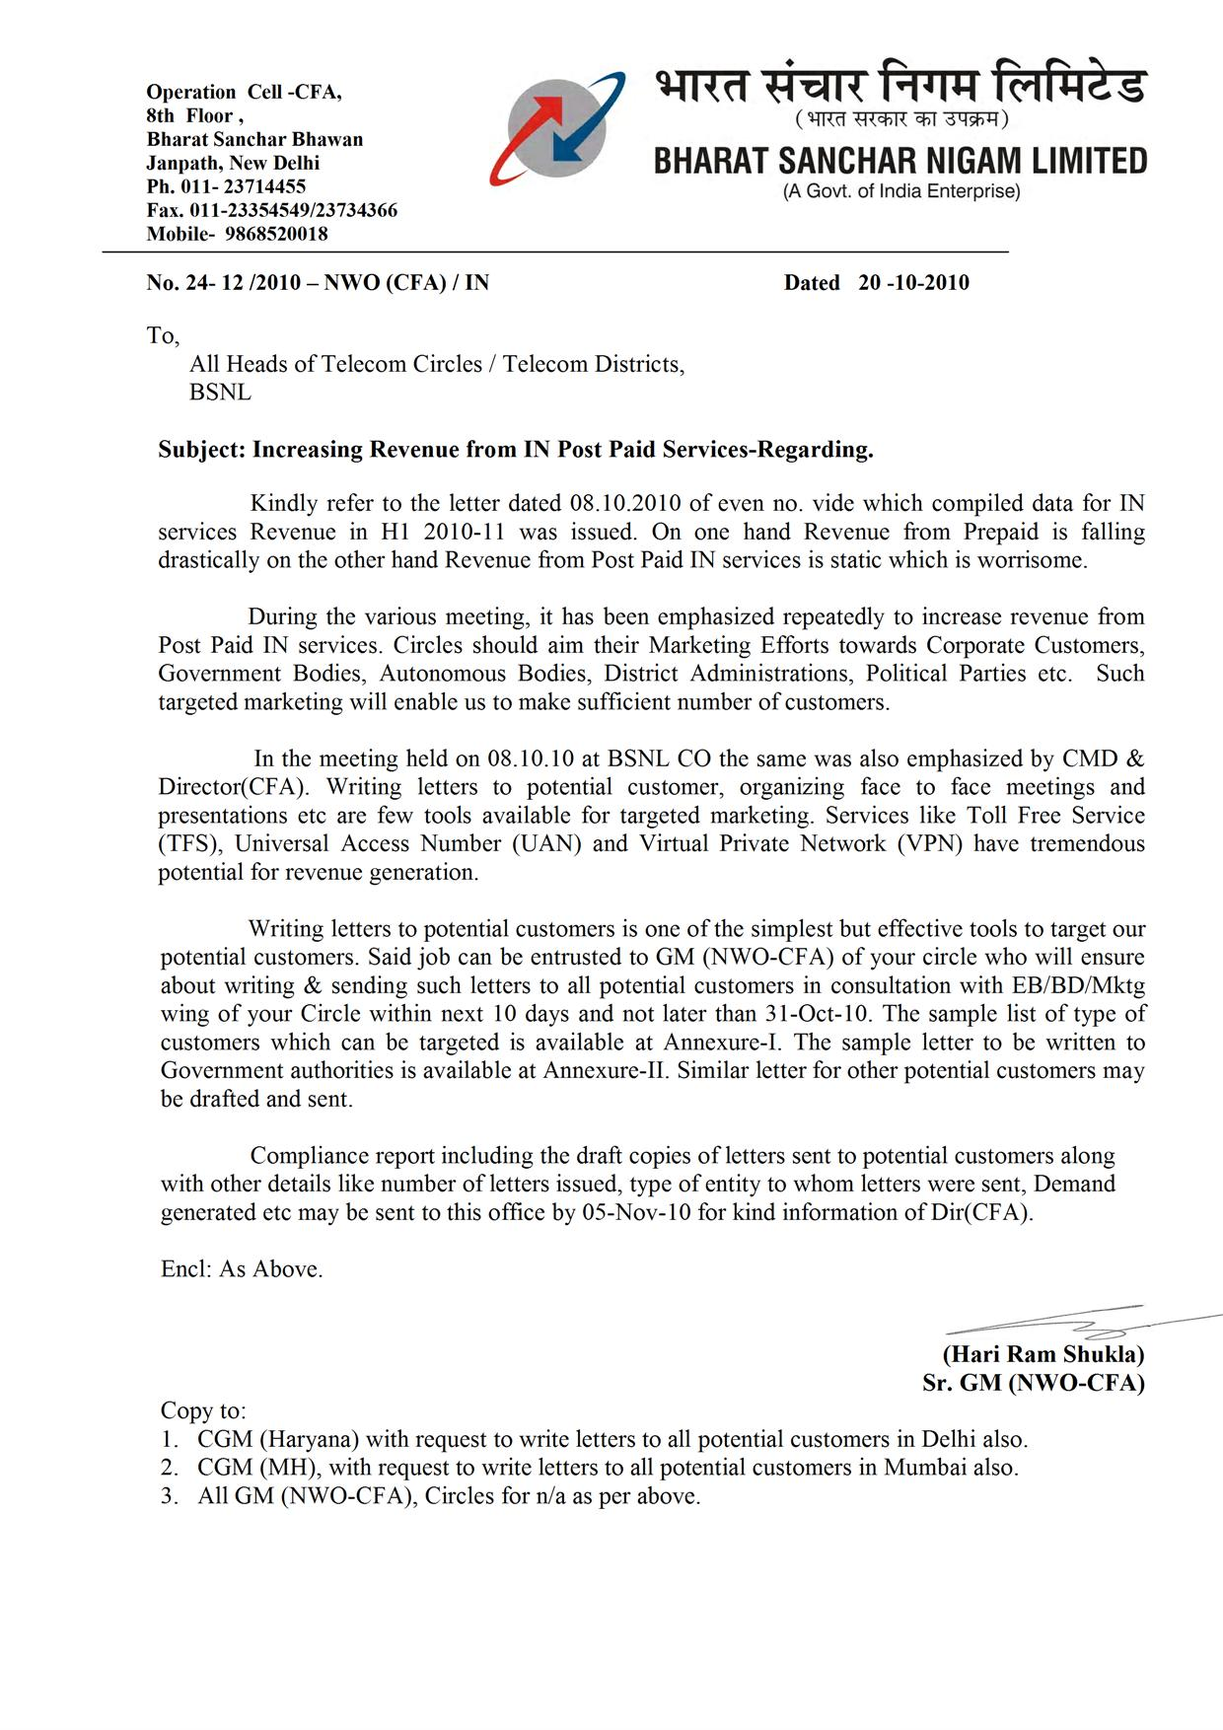
Annexure-1
List of potential Customers (Non Exhaustive) for TFS/UAN Service

S. No. | Industry | Purpose
1 | Airlines | Flight Enquiry
2 | Automobiles | Vehicle Model Enquiry
3 | IT Hardware | IT Related Enquiry
4 | Courier/Packers/Movers | General Enquiry
5 | Schools | Admission Related Enquiry
6 | Private Hospitals | General Enquiry
7 | Travel Agencies | Customers Enquiry and Booking
8 | Banks | Customers Enquiry
9 | Chit Funds | Customers Enquiry
10 | Cosmetic | Customers and Supplier Enquiry
11 | Credit Card Agencies | Customers Enquiry
12 | Coaching Institutions | Customers Enquiry
13 | Central Govt. | Enquiry regarding different welfare schemes
14 | State Government | Enquiry regarding different welfare schemes
15 | District Administration | Enquiry regarding different welfare schemes
16 | Investment/Finance Companies | Customers Enquiry
17 | Hotel Reservation | Customers Enquiry
18 | Insurance Companies | Customers Enquiry
19 | Big Shops | Customers Enquiry
20 | LPG Gas Agencies | Customers Enquiry and booking
21 | Restaurants | Enquiry and order placement
22 | Central PSUs | Customers and Supplier Enquiry
23 | Govt. PSU | Customers and Supplier Enquiry
24 | Autonomous Bodies | Enquiry
25 | Retail Chain | Enquiry
26 | Cell Phone Manufactures | Enquiry
27 | Home Appliances | Enquiry
28 | Paints | Enquiry
29 | Blood Banks | Enquiry
30 | Big Lawyers/Doctors and other Professionals | Enquiry
31 | Construction and Real Estate | Enquiry
32 | Consultants | Enquiry
33 | Electronic Components & Supplies | Enquiry
34 | Others

List of potential Customers (Non Exhaustive) for VPN Service

Housing Societies, Big Corporate having multiple locations, Central Government, State Government, Forest Dept., Associations, Police, Insurance agents etc

Network Operation Cell -CFA,
8th Floor , Room No. 817
Bharat Sanchar Bhawan
Janpath, New Delhi
Ph. 011- 23714455
Fax. 011-23354549

No. …………. Dated ………………..

To,

………………
………………..

Respected Sir,

Different ministries of the government of India are launching welfare Schemes for various cross sections of the society from time to time. Providing a mechanism that is quick, interactive and efficient for dissemination of information regarding these schemes to the targeted populations is critical for its successful implementation. Accordingly concerned ministry have put relevant information on their website to provide easy and single point access to information about several welfare schemes and their various aspects including eligible beneficiaries, types of benefits, scheme details etc.

The internet penetration in country is still very low; literacy rate is still not 100% in many states. Therefore, a direct person to person contact is still the strongest method for exchange of information because of diversity.

In such situations BSNL, Toll Free Service (TFS) is an effective tool for dissemination of information to masses. Already various government entities at different levels have subscribed to this service and getting benefited by the immense power of this tool. One among many such examples is of Kissan Call Center (KCC) scheme of Ministry of Agriculture which handles more than 2 Lacs calls per month all across the country from farmers through BSNL Toll Free Number 1800-180-1551.

Using BSNL TFS Services, all of your multiple offices/Information Call Centers can be called by anyone in general and beneficiaries of the scheme in particular by dialing a single and unique 11 digit number starting from 1800. This service is also accessible from all private operators’ networks . Multiple additional features, such as flexible routing of calls to different destinations based on origin (CLIP), Time of the Call, Day of the Call/Call Time Limit/ Numbers of calls limit(hence complete control over the Bill) etc, are available without any additional charge. For detailed information, enclosed Annexure can be referred to.

I, propose one Toll Free Number for each welfare scheme launched by your Ministry. For any assistance/query/clarification Mr. ………… may be contacted on above mentioned number.

Yours Sincerely,

……………….

